Evaluation Abstract Preparation Guidelines and Template For the 1st Middle East and North Africa Solar Conference MENA-SC (Title in 18-point Times font)
William Shockley, Hans Queisser, and William R. Cherry (List authors on this line using 12 point Times font – use a second line if necessary)

Institute Name, City, State/Region, Mail/Zip Code, Country (authors' affiliation(s) listed here in 12 point Times font – use a second line if necessary)

Abstract — Use 9 point Times New Roman Bold font for the abstract. Set your line spacing to be 10 points rather than single space. Indent the first line by 0.125 inches and type the word "Abstract" in 9 point Times New Roman Bold Italic. This should be followed by two spaces, a long dash (option / shift / minus), two spaces, and then the first word of your abstract (as shown above). Please try to keep the length of your abstract to 300 words or less. Times font is an acceptable substitute for Times New Roman font.

I. Introduction
This evaluation abstract template has been formatted in the manner in which you should prepare your final PVSC manuscript; you may use this Word document as a template. Please use this as an example. Submissions should follow the general appearance if not the exact details of this template. For details or clarification, please contact the Publications Chair at mena-sc@innovationcentre.ae
Please read through this entire template before you start using it to create your abstract! A contributor should remember that:
1) Deadlines to submit your evaluation abstract is:
April 30, 2023!
2) Abstracts must be submitted electronically to the conference website. Manuscripts must be submitted in PDF format. Should you have any difficulty with the electronic submission process, please contact us at mena-sc@innovationcentre.ae
3) If the abstract is not submitted by the April 30, 2023 deadline, you may consider submission to the late news sections of the conference.
4) Evaluation documents are limited to 3 pages.
5) The 3-page Evaluation Document is the most essential part of your abstract submission, since it is the part that will be reviewed by the Program Committee. To help them with their assessment of your paper, please make sure that your Evaluation Document is no more than 3 pages in length, and includes these main points:

- Full title of the paper
- Full author list and affiliation
- Introduction or background of the paper topic
- Main experimental and/or theoretical results
- Analysis of the results, clear exposition of the main findings
- Discussion of the significance of the work for the field
- Summary of the work
- References

This document is being made available as a template for your convenience. If you elect not to use this template, please remember that you must still adhere to the general guidelines for the evaluation abstract shown above.

II. Detailed Text Formatting
Use a two column format. All paragraphs of text, including the abstract, figure captions, and references, should be justified at the left and the right edges.
For the Title, use 18-point Times (Roman) font. Its paragraph description should be set so that the line spacing is single with 6-point spacing before and 6-point spacing after (Format --> Paragraph --> Indents and Spacing). The font description for the Author List and Authors' Affiliation(s) should be 12-point Times. The paragraph descriptions should be set so that the line spacing is single with 6-point spacings before and after. Use an additional line spacing of 12 points before the beginning of the double column section, as shown above.
Using 8.5 x 11-inch paper, the top margin is 0.75 inch, the bottom margin is 1 inch, and the left and right margins are
0.625 inch. Except for Title, Authors and Affiliations, use a double column format. The column width is 3.5 inches and the column spacing is 0.25 inch.
Each major section begins with a Heading in 10 point Times font centered within the column and numbered using Roman numerals (except for Acknowledgement and References), followed by a period, a single space, and the title using an initial capital letter for each word. The remaining letters are in small capitals. The paragraph description of the section heading line should be set for 18 points before, 6 points after, and the line spacing should be set to exactly 12 points.
For the body of your paper, use 10-point Times font and set your line spacing at "exactly 12 points" with 0 points before and after. Indent each paragraph by 0.125 inches.
Further details are provided in the remainder of this paper for specific situations.
A. Major Subsections
TABLE I
Summary of Typographical Settings
 |  |  | Font Specifics |  |  |  |  |  | Paragraph Description
 | Section |  | (Times Roman unless specified) |  |  |  |  |  | spacing (in points) |  |  |  |  |  | alignment |  | indent
 |  |  | style |  | size |  | special |  | line |  | before |  | after |  |  |  | (in inches)
 | Title |  | plain |  | 18 |  | none |  | single |  | 6 |  | 6 |  | centered |  | none
 | Author List |  | plain |  | 12 |  | none |  | single |  | 6 |  | 6 |  | centered |  | none
 | Affiliations |  | plain |  | 12 |  | none |  | single |  | 6 |  | 6 |  | centered |  | none
 | Abstract |  | bold |  | 9 |  | none |  | exactly 10 |  | 0 |  | 0 |  | justified |  | 0.125 1st line
 | Index Terms |  | bold |  | 9 |  | none |  | exactly 10 |  | 0 |  | 0 |  | justified |  | 0.125 1st line
 | Headings |  | plain |  | 10 |  | small caps |  | exactly 12 |  | 18 |  | 6 |  | centered |  | none
 | Subheadings |  | italic |  | 10 |  | none |  | exactly 12 |  | 6 |  | 6 |  | left |  | none
 | Body Paragraphs |  | plain |  | 10 |  | none |  | exactly 12 |  | 0 |  | 0 |  | justified |  | 0.125 1st line
 | Equations |  | Symbol font for special characters |  |  |  |  |  | single |  | 6 |  | 6 |  | centered |  | none
 | Figures |  | 8 to 10 point sans serif (Helvetica) |  |  |  |  |  | single |  | 0 |  | 0 |  | centered |  | none
 | Figure Captions |  | plain |  | 9 |  | none |  | 10 |  | 0 |  | 0 |  | justified |  | none, tab at 0.5
References |  | plain |  | 9 |  | none |  | 10 |  | 0 |  | 0 |  | justified |  | 0.25 hanging

As shown, denote subsections with left justified 10-point Times Italic. Order them with capitalized alphabetic characters (A, B,...). Follow the letter designation with a period, a single space, and then the subsection title capitalizing the first letter of each word. The paragraph description of the subsection heading is set to "exactly 12-point" line spacing with 6 points before and after.
B. Equations
Equations should be centered in the column and numbered sequentially. Place the equation number to the right of the equation within a parenthesis, with right justification within its column. An example would be
(1)
Make sure that any subscripts in your equations are legible and are not too small to read! When referring to an equation, use the number within parenthesis. For example, you would usually refer to the first equation as (1) rather than equation (1). If possible, use the Symbol font for all special characters, or better yet, use Equation Editor™ or MathType™. The paragraph description of the line containing the equation should be set for 6 points before and 6 points after. The paragraph spacing will need to be set to "single" rather than "exactly 12 point" so that the height will autoscale to fit the equation.

III. Figures AND Tables
The use of color in figures and photos is recommended. Please consider the use of different line styles (dashes, dots, etc.) in plots to ensure clarity. See example. Please use jpg format for all images and compress the size.
Figures and tables should be positioned within the text. Illustrations and graphics may be one- or two-columns wide and should include captions or titles, as in the examples below.
Figures should utilize as much of the column width as possible in order to maximize legibility. Use a sans serif font, such as Helvetica or Arial. Helvetica and Arial are larger and much easier to read than Times. Using 8- to 10-point Helvetica usually results in a legible figure. Do not use any font smaller than 8-point! It must be legible. When referring to a figure, use the abbreviation Fig. followed by its number. Place figure captions directly below each figure. Use 9-point Times with the paragraph spacing set at "exactly 10 points". Set a tab at 0.5 inch. Type "Fig. #." (# is the numeral) then tab over to the 0.5 inch mark before beginning the text of the figure caption. Note that figure captions are always (left and right) justified, rather than centered, even if they are less than a single full line in length. See the captions for Fig. 1.
Within Microsoft Word there are several options for placing figures within your paper. Often the easiest is to insert them between existing paragraphs allowing the figures to remain in that relative position. The paragraph description where the figure is inserted must be set to "single" spacing rather than "exactly 12 points" in order to allow the line to autoscale in height to display the entire figure. Some disadvantages of this approach are that you don't have total flexibility in placing figures, and that the figures will move as text is inserted or deleted in any part of the document before the figure. If you elect to use this approach, it is recommended that you nearly complete the editing of your text before inserting any figures. Remember to allow room for them, however. Then begin inserting figures starting from the beginning of your document. Do not lump all figures at the end of the paper!
If you have difficulties with the titles on your figures, you can always elect to add in the titles as separate text boxes, rather than importing the titles with the graph. This is sometimes helpful in getting a lengthy vertically-oriented title to display correctly.

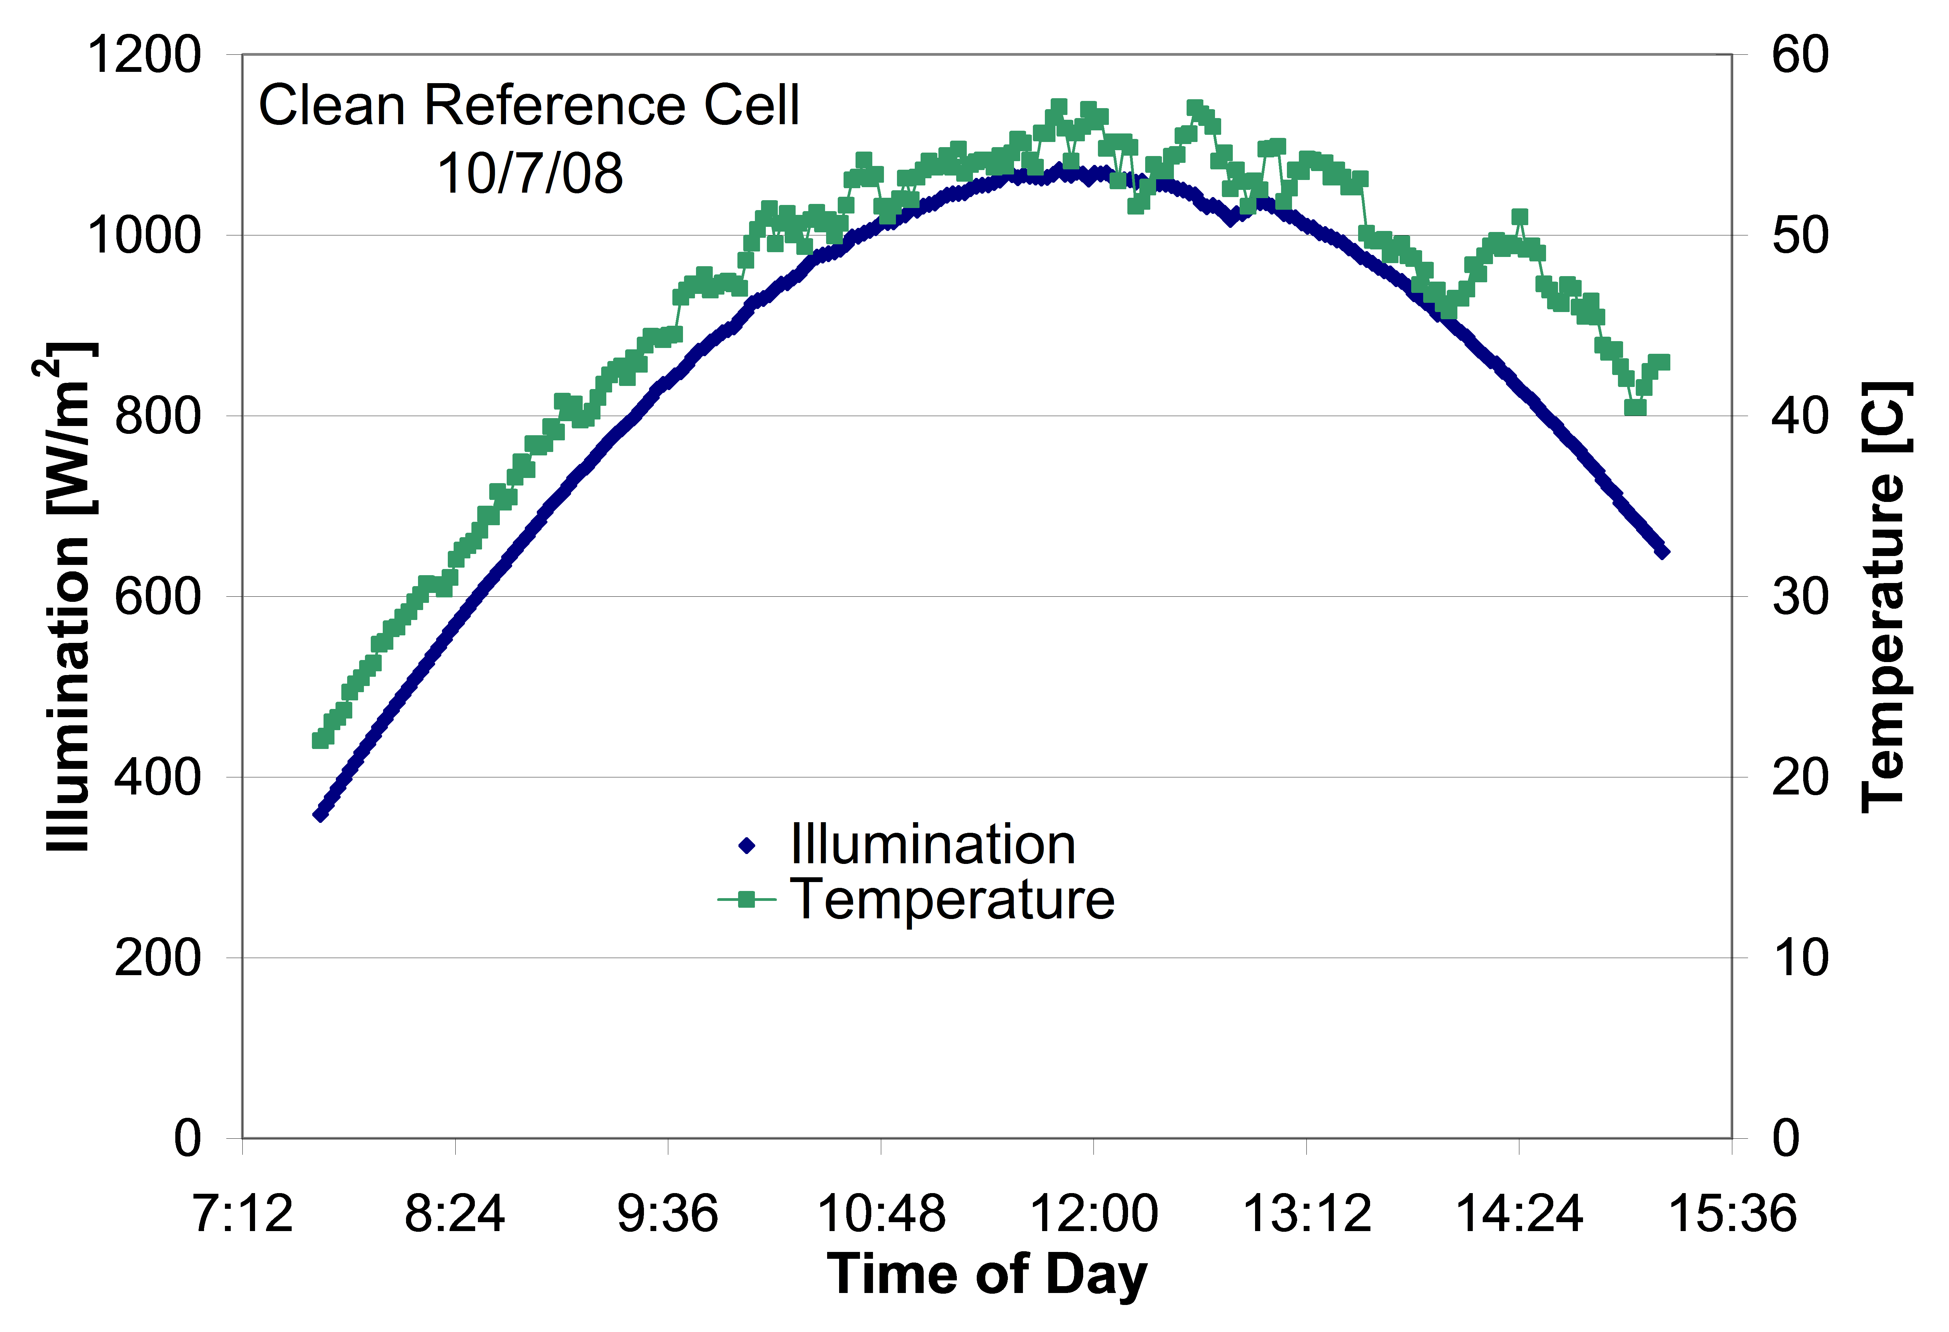

Fig. 1. Example of readable plot using different colors and line styles for clarity.

Notice that prior to the graph, a single 12-point line is used to separate the preceding text from the graph. The equivalent of a blank line should exist between the bottom of the graph (the x-axis caption) and the figure caption. After the figure caption, there should be a single 12-point blank line before the text resumes.
More flexibility is obtained in inserting figures if you can place them exactly where you would like them to be on a page. This can be accomplished by inserting the figure, selecting the figure, and then choosing "Format Picture...". Various settings allow you to place the figure at an absolute position on a page; specify if the text is supposed to flow around the figure or if the figure should move with the text, etc. If you elect to let the text flow around the figure, then remember that you will have to insert a separate text box for the caption, otherwise the figure caption is likely to become separated from the figure.
Table I on the second page was inserted using "Insert", "Text Box", creating the text contained in Table I, and then formatting the text box using all the settings available under "Format", "Text Box...". Table I also serves as an illustration of one of the rare instances when the double column format requirement can be violated. When possible, use a table editor or tabs to create tables. Please do NOT use spaces to align the columns of your table. Also do NOT use the “columns” feature to create tables. When possible the table data should be centered within a single column. If there is not enough space left on the page to allow for your table, end your page and continue on the next page.

IV. Citing Previous Work
When referencing a journal article [1], a conference digest article [2] or a book [3], place the reference numbers within square brackets. To simultaneously cite these references [1]-[3] use the format just demonstrated. The reference list is the last section and references are listed in the order cited. Use 9 point Times. The paragraph description is set for a line spacing of exactly 10 points with 0 point spacing before and after. A 0.25 inch hanging indention should be specified.
References should be detailed. For journal articles, list all authors by initials and last name, the title of the paper in quotations (capitalizing only the first letter of the first word), the journal name in italics, the volume number, the issue number, the page numbers, and the date. Use the examples provided [1]–[3] as a guide.

References
[1] M. Yamaguchi, A. Khan, S. J. Taylor, M. Imaizumi, T. Hisamatsu, and S. Matsuda, "A detailed model to improve the radiation-resistance of Si space solar cells," IEEE Transactions on Electron Devices, vol. 46, pp. 2133-2138, 1999.
[2] H. J. Hovel and J. M. Woodall, "The effect of depletion region recombination currents on the efficiencies of Si and GaAs solar cells," in 10th IEEE Photovoltaic Specialist Conference, 1973, p. 25.
[3] A. L. Fahrenbruch and R. H. Bube, Fundamentals of Solar Cells. New York, New York: Academic Press, 1983.

